
EJB
By:
Mr.Satyendra Singh
Department of Computer Science & Engineering, ABESIT College of Engineering, Ghaziabad.

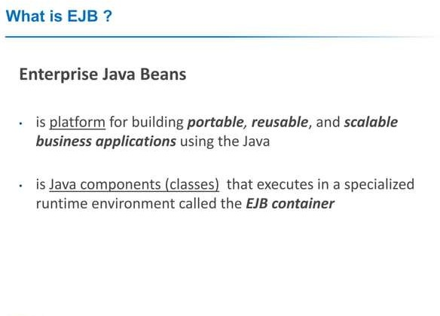

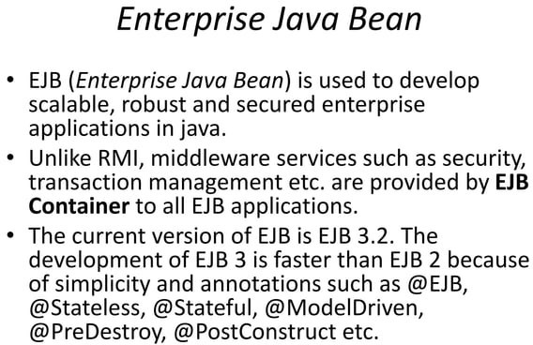
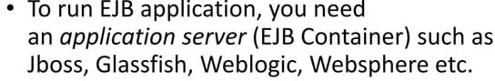

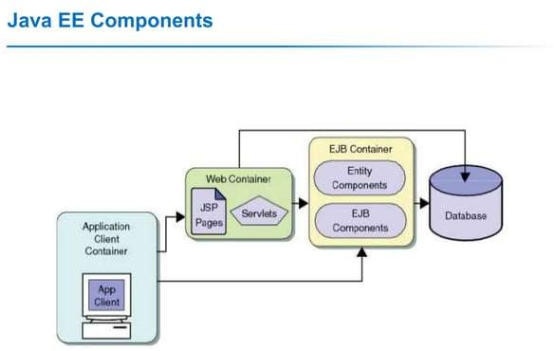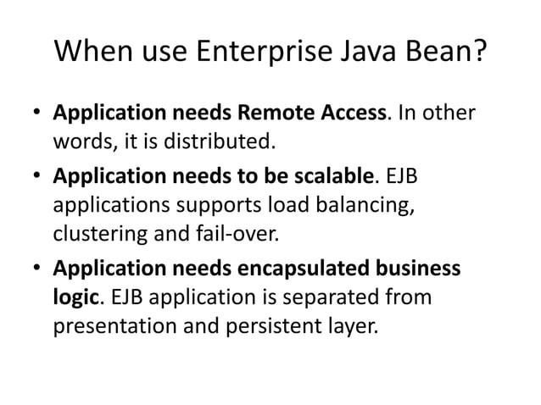

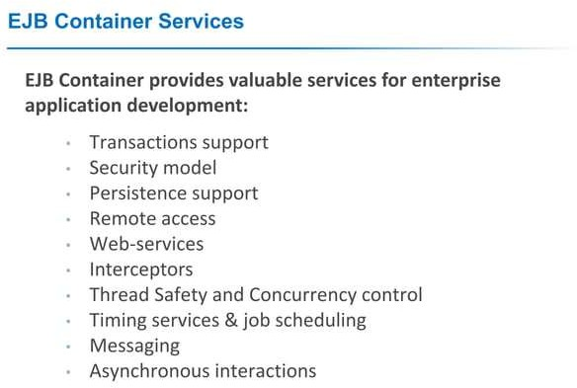

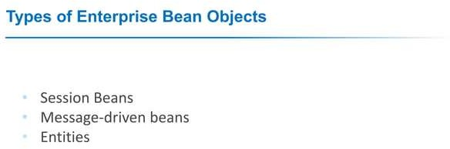

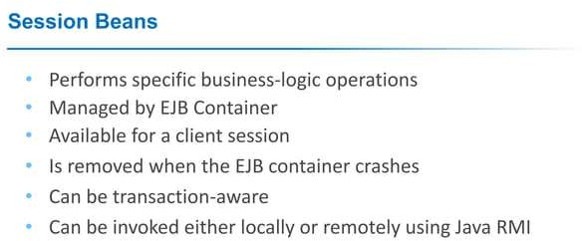
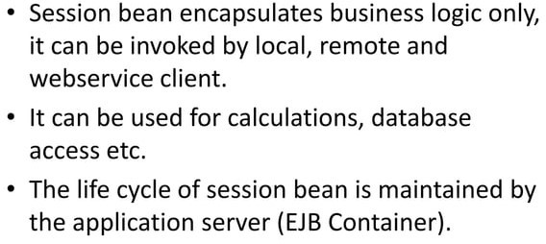

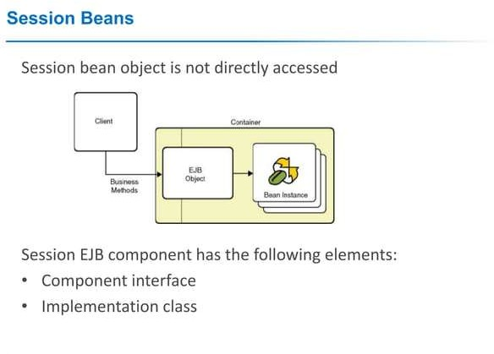

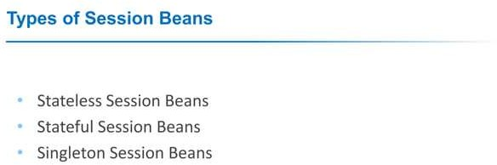

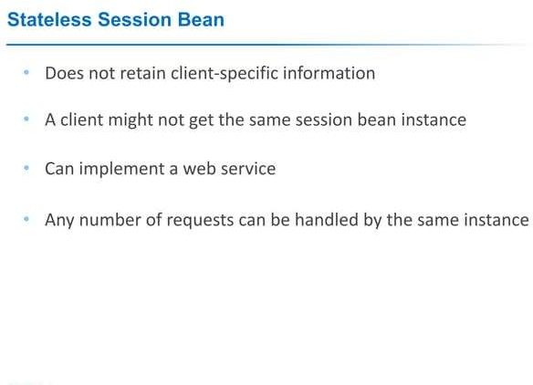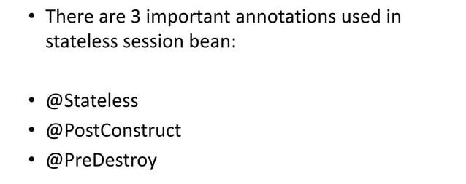

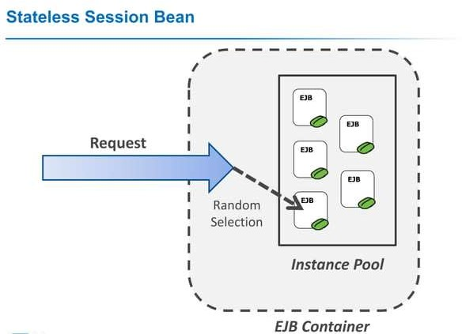

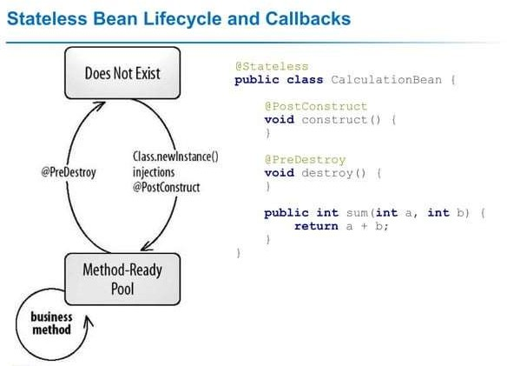

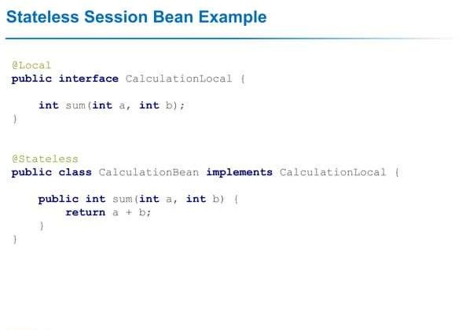

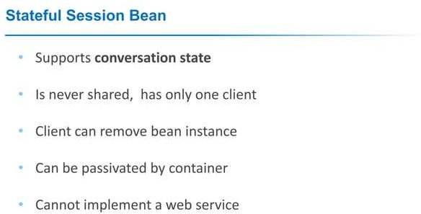
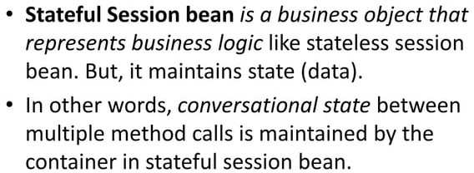
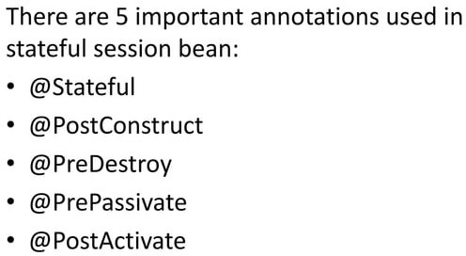

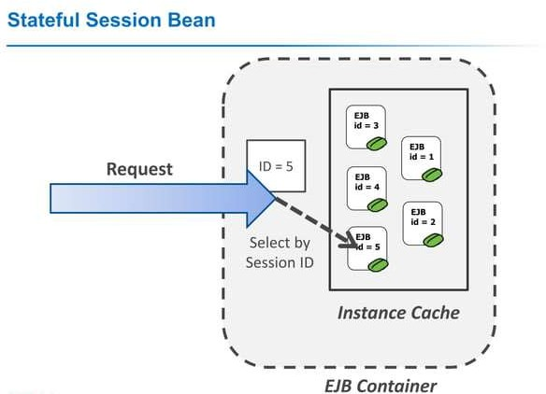

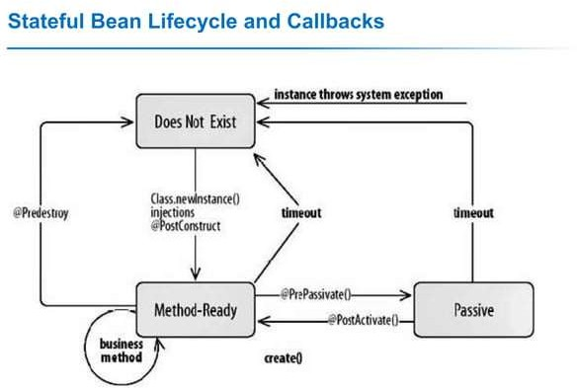

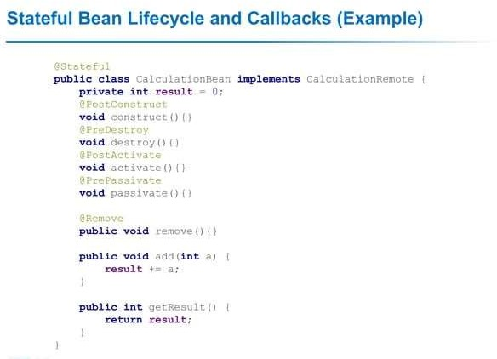

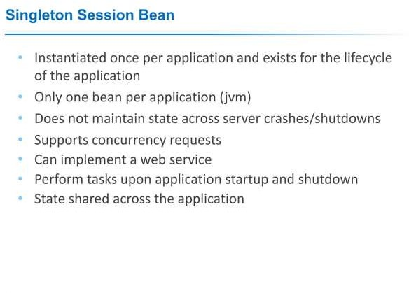

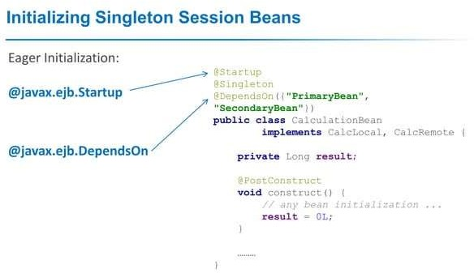

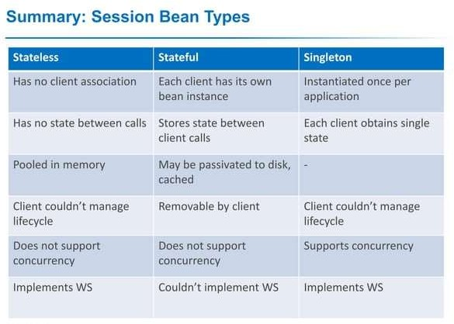



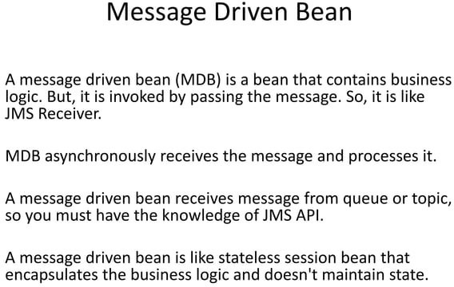

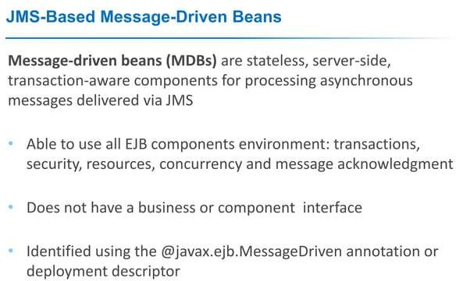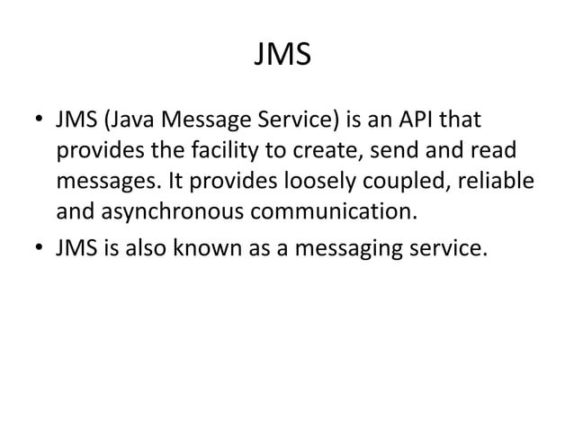

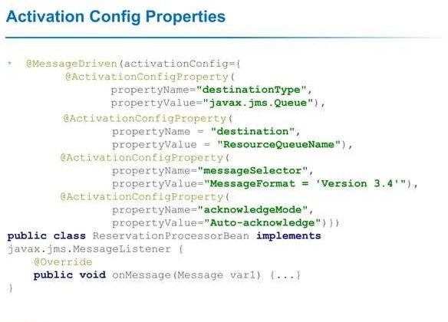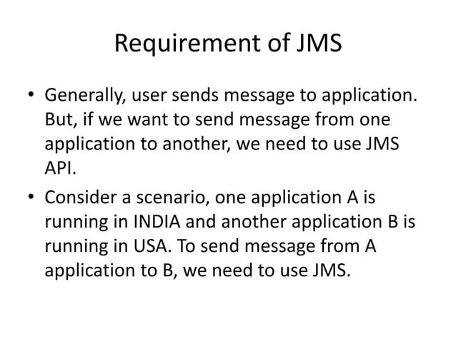

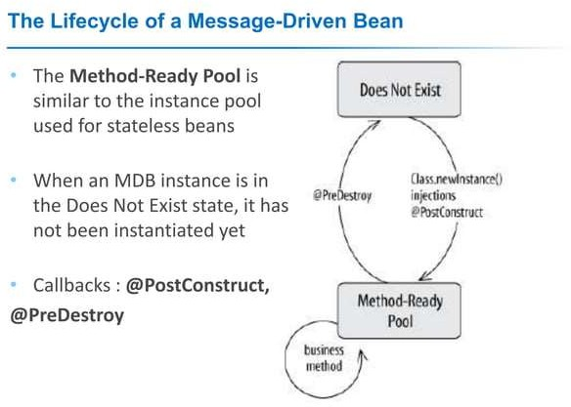

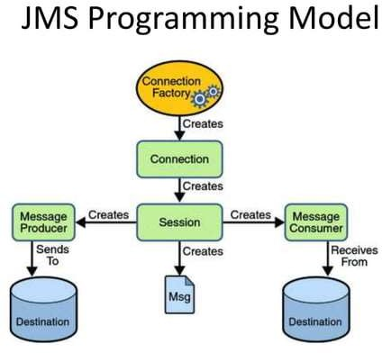

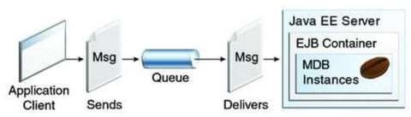

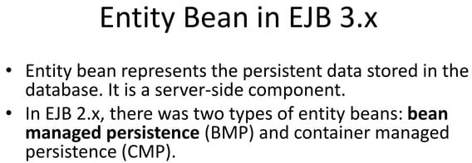

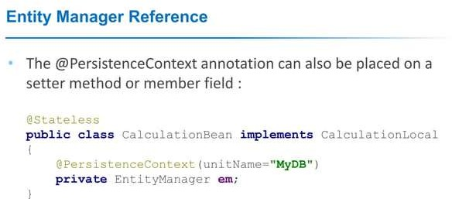

Enterprise Bean

<<Home Interface>>
AccountHome
create() find() remove()
<<Remote Interface>>
Account debit() credit() getBalance()
<<Enterrpise Bean class> AccountBean ejbCreate()
ejbFind()
ejbRemove() debit() credit() getBalance()
Deployment Descriptor
name = AccountEJB class = AccountBean home = AccountHome remote = Account type = Entity transaction = required
…..

AccountHome Interface

import java.rmi.RemoteException; import javax.ejb.CreateException; import javax.ejb.FinderException; import java.util.Collection;
public interface AccountHome extends javax.ejb.EJBHome {
//create methods
Account create (String lastName, String firstName) throws RemoteException, CreateException, BadNameException;
Account create (String lastName) throws RemoteException, CreateException;
// find methods
Account findByPrimaryKey (AccountKey primaryKey) throws RemoteException, FinderException;
Collection findInActive(Date sinceWhen)
throws RemoteException, FinderException, BadDateException;
}

Account Interface
import java.rmi.RemoteException;

public interface Account extends javax.ejb.EJBObject
{

BigDecimal getBalance() throws RemoteException;
void credit(BiGDecimal amount) throws RemoteException; Void debit(BigDecimal amount) throws RemoteException,
InSufficientFundsException;
}

AccountBean class
public class AccountBean implements javax.ejb.EntityBean {
// life cycle methods from home interface
public AccountKey ejbCreate (String latName, String firstName) throws … {…} public AccountKey ejbCreate(String lastName) throws …{…}
public AccountKey ejbFindByPrimaryKey(AccountKey primarykey)… {…} Public Collection ejbFindInactive( Data sinecWhen).. {…}
// business methods from remote interface public BigDecimal getBalance() {….}
public void credit(BigDecimal amt) {…}
Public void debit(BigDecimal amt) throws InsufficientFundException {….}
// container callbacks from EntityBean container public ejbRemove( ) throws RemoveException{ …} public void setEntityContext(EntityContext ec) {…} public unsetEntityContext(EntityContext ec) {…} public void ejbActivate() {…}
public void ejbLoad() {….} public void ejbStore() {….}
}

Deployment Descriptor
…
<entity-bean>
<ejb-name>AccountEJB</ejb-name>
<home>com.wombat.AccopuntHome</home>
<remote>com.wombat.Account</remote>
<ejb-class>com.wombat.AccountBean</ejb-class>
<persistence-type>Bean<\persistence-type>
<primary-key-class>com.wombat.AccountKey</primary-key-class>
</entity-bean>

…
<container-transaction>
<method>
<ejb-name>AcoountEJB</ejb-name>
<method-name>*</method-name>
</method>
<trans-attribute>required</trans-attribute>
</container-transaction>



Questions ?

35

